**Grade 4**

**Sivanarthanalayam**

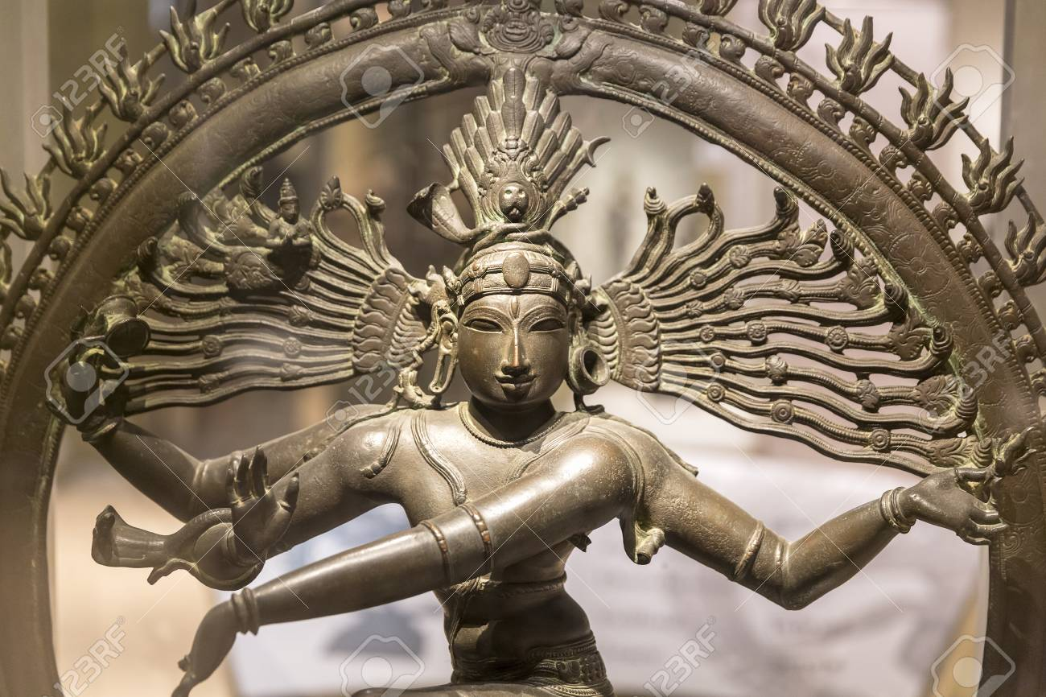

**By.Smt.Sivaraji Sivakumar**

**Jathiswaram**

1. Jathi + swaram make Jathiswaram.

2. Jatheswaram is Nirutha piece which includes only jathis and korvai.

3. It is the second stage performance in the Natiya Markam.

4. Jathiswaram is a pure dance with no special meaning.

5. It starts with Theermanam and then follows onto Korvais.

6. Jathiswaram is divided by Pallavi, Anupallavi and Charanam.

7. Pallavis repeat many times for korvais.

8. Jathiswarams are in a variety of Ragams and Thalams, each invoking a different mood and set of rhythmic patterns.

Example: Kalyani and Vasantha.

**Sabtham**

1. Sabtham is the third stage program in the Natiyamarkam.

2. This is the item which brings Abinaya (facial expression)at first on the stage.

3. Sabthams are accompanied by devotional songs.

4. The word “Sabtha” means seven, Normally Sabthams are set in Misra chappu Thalam and Ragamaliga Ragam.

5. Sabthams are divided into many kandikas.

6. Through the Sabtham, it describes about the greatness of deities like Krishna, Siva and Murugan.

7. Sabthams include small Sanchari bhanvas (small story related about that particular sabtham)

**Gowthwam**

1. Gowthwan came from the Sanskrit word ‘Koutakam’ means praise.Gowthwam is usually dance praise of a deity.

2. It’s an invocatory item.

3. Olden days Gowthwams were perform in temple rituals, at present it’s also performed on the stage.

4. Gowthams begins with a rhythmic dance sequence and continues with verses praising the deity and ends with rhythmic syllables. However, Gowthwams can also be dedicated to kings or Noblemen.

5. Normaly Gowthwams stats with the sotkatu Thith thith thei, ends with Thaku Theku Thakita.

**Kinkini**

1. Kinkini means Salangai.

2. The bells are made of bronze.

3. Each bell is a spherical shape.

4. Bells used to be tied onto black rope which was tied onto dancer’s leg. Between each pair of bells there was a one inch gap.

5. For a long time, the left leg had 100 bells and the right leg had two hundred. But nowadays the right and left leg have a 30 – 50 bells sewn on a leather band.

6. Salangai is tied onto the dancer’s feet, it makes a pleasant sounds.

7. It also helps maintain the rhythm of the song.

8. The god of Kinkini is ‘Tharakaranam’ or ‘Nadchatiram’.

**Theermanam**

1. Theermanam comes at the end of a Korvai.

2. It has solkattu in all three kalams.

3. Theermanam is made with Jathis.

4. Theermanam ends with ‘Kita taka thari kita Thom’, or ‘Thathing kina Thom’.

5. Theermanam is essential to end a Korvai or a composition.

6. Theermanam means the end of a rhythmic pattern.

**Thandavam**

1. Thandavam consists of fast footwork, forceful movements, quick turning, majestic postures and etc.

2. This belongs to Nirutham.

3. It has beautiful poses.

4. History tells us that Thandavam was created by Lord Siva who taught it to ‘Thandu Munivar’ and then Thandu Munivar taught it to Boologa people. (People who live in Earth.)

5. This dance cannot be performed part by part.

6. It should be performed with the song and with the rhythm.

7. In the olden days, this dance was only danced by men but now it is danced by girls too.

8. There used to be 108 Thandavam which then reduced to 64 and now they have 7 famous Thandavams. They are

1. Ananda Thandavam, 2. Gowrava Thandavam

3. Santhiya Thandavam 4. Samkara Thandavam

5. Thiripura Thandavam 6. Kalika Thandavam

7. Urthuva Thandavam

**Definition of a Dancer ( Pathra Lakshanam)**

**1. Physical Feature:-**

The dancer must have a good young appearance, limbs that are beautiful with supple arms and feet, sharply arms and hand that move like a graceful creepers, a face that is pleasing enough to portraya myriad emotions with large expressive eyes, slender body, pleasant, well fine teeth with attractive smile,, slim waist, not very fat or thin, neither too tall or too short, fine rows of teeth and well-formed long fingers, and lips painted red like the cherry fruit . The neck described like a spiral conch.

Abinayadarpanam (a dance book written by Nandikeswara) says that, it is understood that the nayaki should be very lovely, young, with full round breasts, self-confident, charming, agreeable, dexterous in handling the critical passages, skilled in steps and rhythms, quite at home and stage, expect in posing hands and body, grateful hand gesture with wide open eyes with charming lotus-face.

**2. Character appearance:-**

The best dancer is one, who co-ordinates exactly with the tala or rhythmic beats and laya or tempo of the vocal strains and instrumental music, moving in delicate and sprightly style, and expressing the correct meaning of the song. The true dancer is connected to the beauty of the body, Dancer should have Self-confidence, should Know when to start and when to stop, Able to perform Abinayam, Observe the time beats, Good personality, Eager to learn art, Patient and Pleasing, Group Coordinate with others, Obedient to guru, Devotional to god, and Respect to others.

**Differences between Jathiswaram and Sabtham**

1. Jathiswaram is a Nirutham and Sabtham is a Niruthiyam.

2. Jathiswaram is the second stage programme but Sabtham is the third.

3. Jathiswaram is divided by Pallavi, Anupallavi and Charanam but Sabtham is divided by Kandikai.

4. Jathiswaram is filled with footwork but Sabtham is full of facial expression.

5. Sabtham may change ragam for each Kandikai but Jathiswaram has the same ragam throughout.

**Similarity between Jathiswaram and Sabtham**

1. Jathiswaram and sathams are in the Natiya Markam.

2. Both items set with beat and rhythm.

3. Both need imagination and creativity.

4. Both dances satisfy the audience.

**Lashyam**

The term “lashya” in the context of Hindu mythology describes the dance is an element which by lord Parvathi as its expresses and happiness and filled with grace and beauty. Lashya is an element which is graceful, delicate and expresses emotions on a gentle movement. It’s dance by women. Parvathy taught lashya to Usha (daughter of sage Banasura) then she passed on this art to Kobikas who live in Duvaraka.

**Diffrents between thandavam and lashyam**

1. Thandavam is danced by lord Siva but lashyam dance by lord Siva’s wife Pharvathi.

2. Thandavam is nirutham but lashya is niruthiyam

3. Thandavam has hard and forceful steps but lashya has soft and very gentle movements.

4. Thandavam is performed by men but lashya performed by women.

5. Thandavam has footwork and poses but lasyam has full of facial expression.

**1. Pathaka Hashtha viniyogam**

1. Natyarambhe - Beginning of the Dance

2. Varivahe - Group of clouds

3. Vane - Forest

4. Vastunishedhane - Forbidding things

5. Kujasthale - Breast

6. Nishayamcha - Dark night

7. Nadhyaam - River

8. Amaramandale - Heaven

9. Thurange - Horse

10. Kandane - Cut

11. Vayow - Wind

12. Shayane - To sleep

13. Gamanodhyame - Leading the group

14. Prathapecha - Praise

15. Prashadhecha - To wish well

16. Chandrrikayam - Moonlight

17. Ghanathape - Unbearable heat

18. Kavatapatane - Closing and opening of the door

19. Sapthavibhaktiyarthe - Seven cases

20. Tharangake - Small waves

21. Veedhipraveshpavepi - Entering the street

22. Samathvecha - Equality

23. Angaragave - Touching the body

24. Aharthmarrthe - Pointing one self

25. Shapathechapi - Vow

26. Thushnibhavani dharshane - Being silent

27. Talapathrecha - Writing on the palm leaf

28. Khetecha - Shield

29. Drawyadi parshane thatha - Touching things

30. Ashirvadakriyayamcha - Blessing

31. Nirupash deshtashdasya bhavane - Emperor

32. Thatra thatretivachane - here and there

33. Sindowthu - Ocean waves

34. Sukrutikrame - Succession of good deeds

35. Sambodhane - Addressing

36. Purogepi - Moving Forward

37. Khadgaroopashyadharane - Holding Sword

38. Masse - Month

39. Samvathsare - Year

40. Varshathine - Rainy day

41. Sammaryane thatha - Sweeping

Evamarthesu yuyathe pathaha hashtha bhava naga

**2. Tripathaka Hashtha Viniyogam**

1. Makute - Crown

2. Vrukshapavepi - Branches of tree

3. Vajre - Indira’s Weapon

4. Thadravasave - Lord Indra

5. Kethaki kushume - Ketaki flower

6. Dheepe - Lamp

7. Vanhijuvalavizrumban - Fire

8. Kapothe - Pigeon

9. Patralekayam - Writing a letter

10. Bhanarthe - Shooting an arrow

11. Parivarthane - Circular movements

Yujathe tripathakoyam kati tho paratho thamahi.

**3. Arthapathaka Hashtha viniyogam**

1. Pallave - Young Leaf

2. Phalake - Wooden Plank

3. Theere - River

4. Ubayorithivasake - Showing both / denote two

5. Krakache - Saw

6. Surikayamcha - Small knife

7. Dhuvaje - Flag

8. Gouda - Temple tower or pyramid

9. Srungayoho - Horns

Yujathe arthapakoyam thath thath karma prayogake.

**4. Kartharimuga Hashtha Viniyogam**

1. Stipumsa yostu vishveshe - Difference between the man and women

2. Viparya sapathepiva - This or that

3. Lundane - Rolling

4. Nayanamthecha - Corner of the eyes

5. Marane - Death

6. Bhedabhavane - Difference

7. Vidyu dharthe - Lightning

8. Ehashaiya virahe - Separation

9. Pathanethatha - To fall

10. Lathayam - Creeper

Yujathe jashthu chakara kartharimugaha.

**5.Mayura Hashtha Viniyogam**

1. Mayurakyo - Peacock

2. Lathayamcha - Creeper

3. Shakune - Omen bird

4. Vamanethatha - Vomiting

5. Alakasyapa nayane - Untangling of hair

6. Lalata thilakecha - Applying pottu

7. Nadyutha hastha nikshepe - Sprinkling river water

8. Sastra vadhe - Discussing shastra / tradition

9. Prasidhake - Famous

Eva mardheshu yujathe mayurahara bhavanaka.

**6.Arthachandra Hastha Viniyoga**

1. Chandre - Moon

2. Krishnatami bhaji - 8 days of decreasing moon

3. Galahastartha kepicha - Pushing someone by their neck

4. Bhallayuthe - Spear

5. Devathanam abishechana karmini - Offering to God

6. Bhukpatre - Dinner plate

7. Udpave - Birth

8. Kadyam - Waist

9. Chinthayam - Thinking

10. Athmavachake - Spirit/soul

11. Dhyanecha - Meditation

12. Prathane chapi - Prayer

13. Anganam sparshanetatha - Touching limbs

14. Acervatha kiryayamcha - Blessing

15. Prakruthanam namashhare - Namaskarithal

Arthachandroni yujathe.

**7. Arala Hashtha Viniyogam**

1. Visharthe amruthapaneshu - Drinking poison

2. Prachanda pavanepicha - Violent wind

**8. Shukathunda Hashtha Viniyogam**

1. Bhanaprayoge - Shooting Arrow

2. Kundarthe - Spear

3. Alayash yashya smuthikrame - Remembering the past

4. Marmodhyam - Murmuring sound

5. Ugrabhavehsu - Violent

Shugathundoni yuyathe

**9. Mushti Hashtha viniyogam**

1. Sthire - Firm

2. Kyagrake - Grasping the hair

3. Dhardiye - Courage

4. Vashthuva dhinamcha dharane - Holding things

5. Mallanam uthapavepi - Wrestling

Mushti Hashtha Mishyathe.

Smt. Sivaraji Sivakumar Sivanarthanalayam